Idea/Game Concept

The game we came up with is called “The Revenge of the Shade”. It is influenced by the game “Dead by Daylight”.

In our game, there are 6 generators located around the map and the Survivor will have to obtain 3 out of the 6 generators that will allow him to change into another character that has abilities to kill the Killer who will try and kill the Survivor throughout the game.

Project Schedule

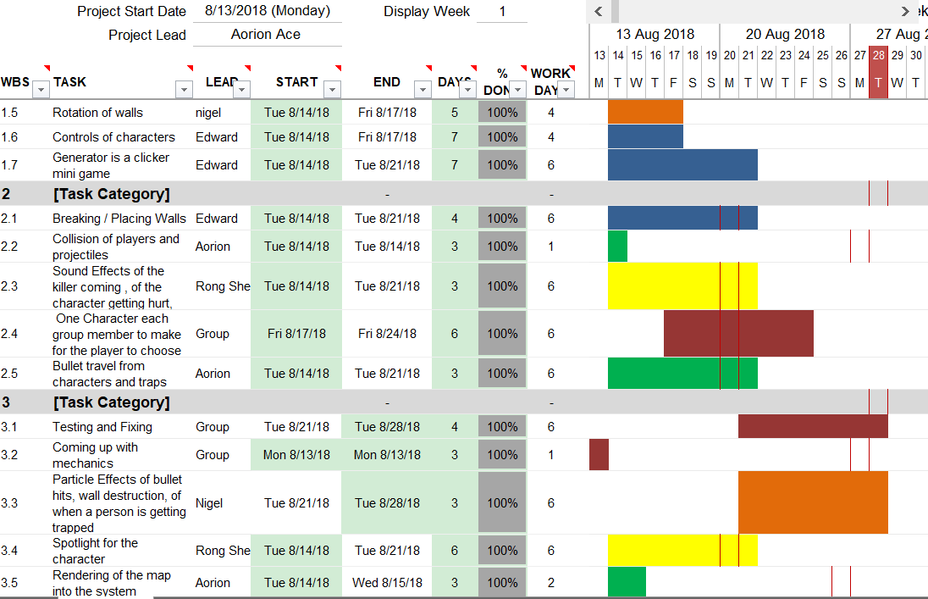

Screenshots of our game

Multiplayer

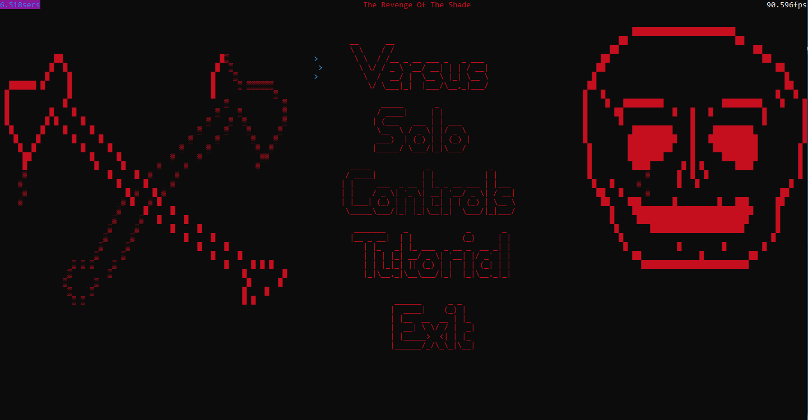

With Fog of war

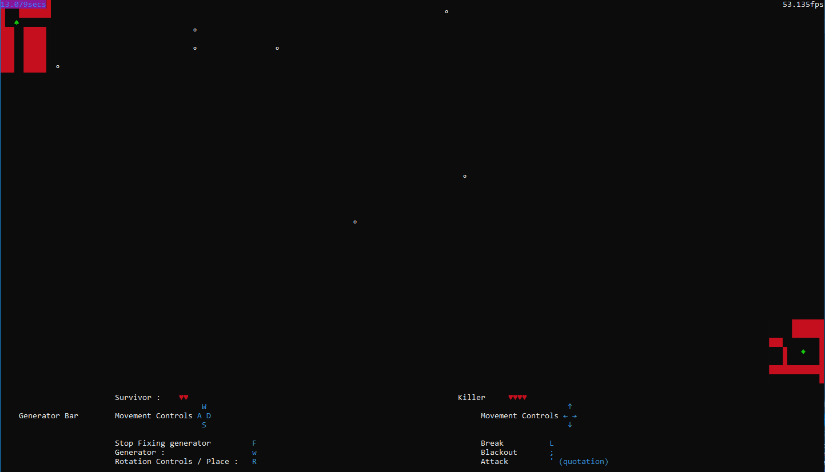

Without Fog of war

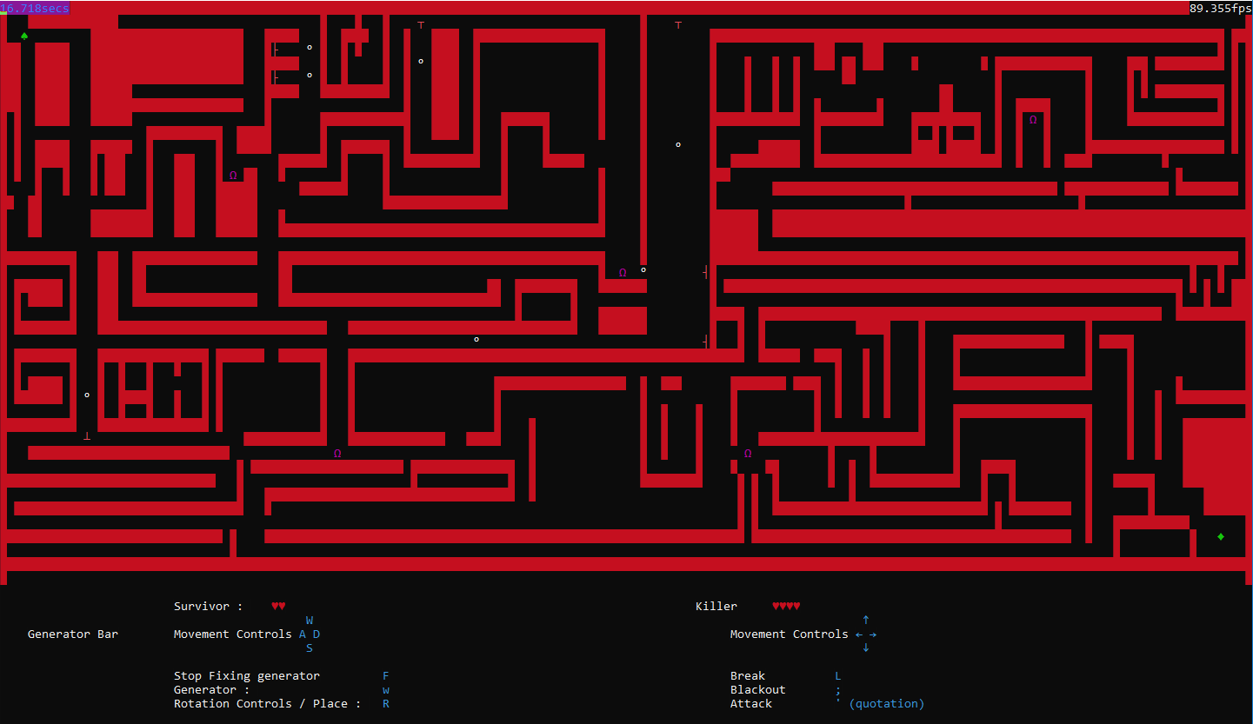

Character Selection Screen

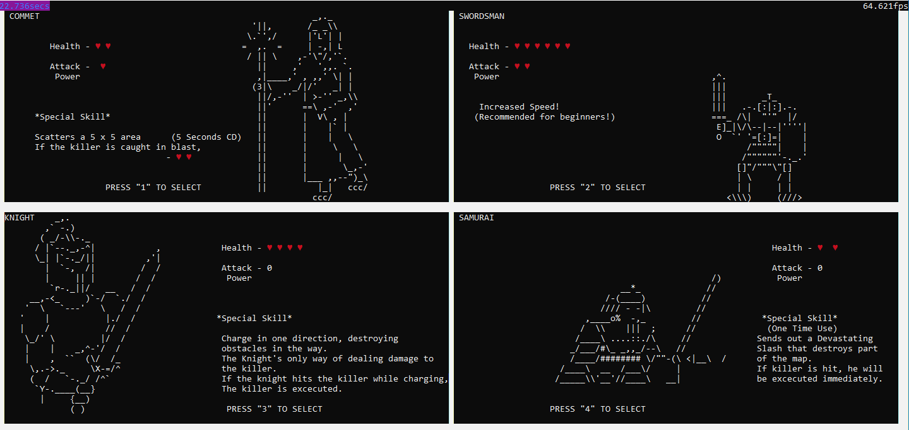

**Singleplayer**

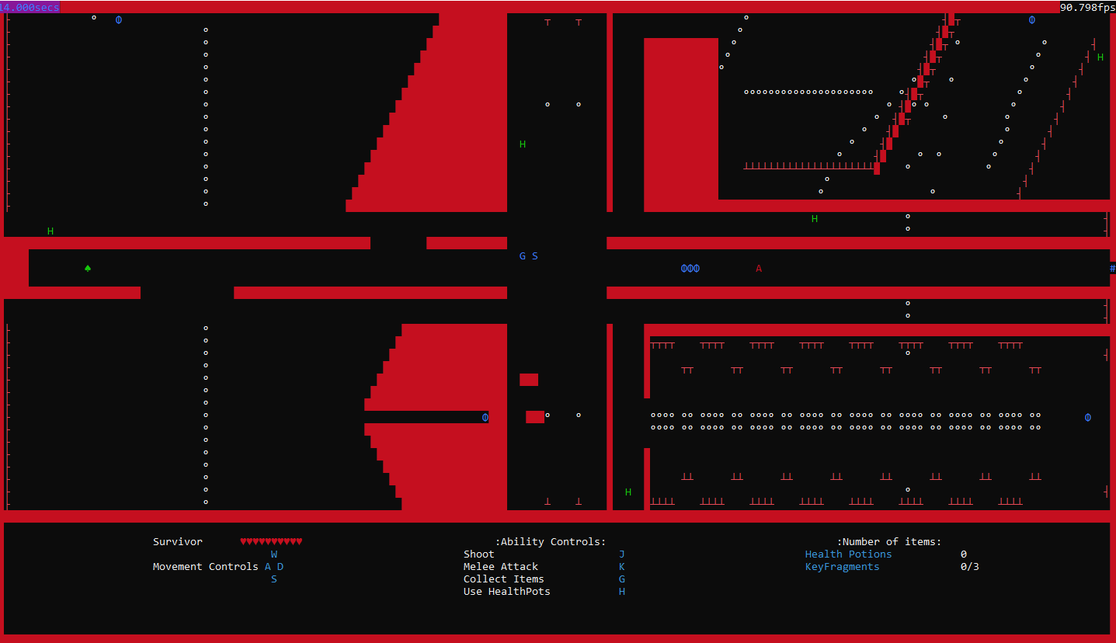

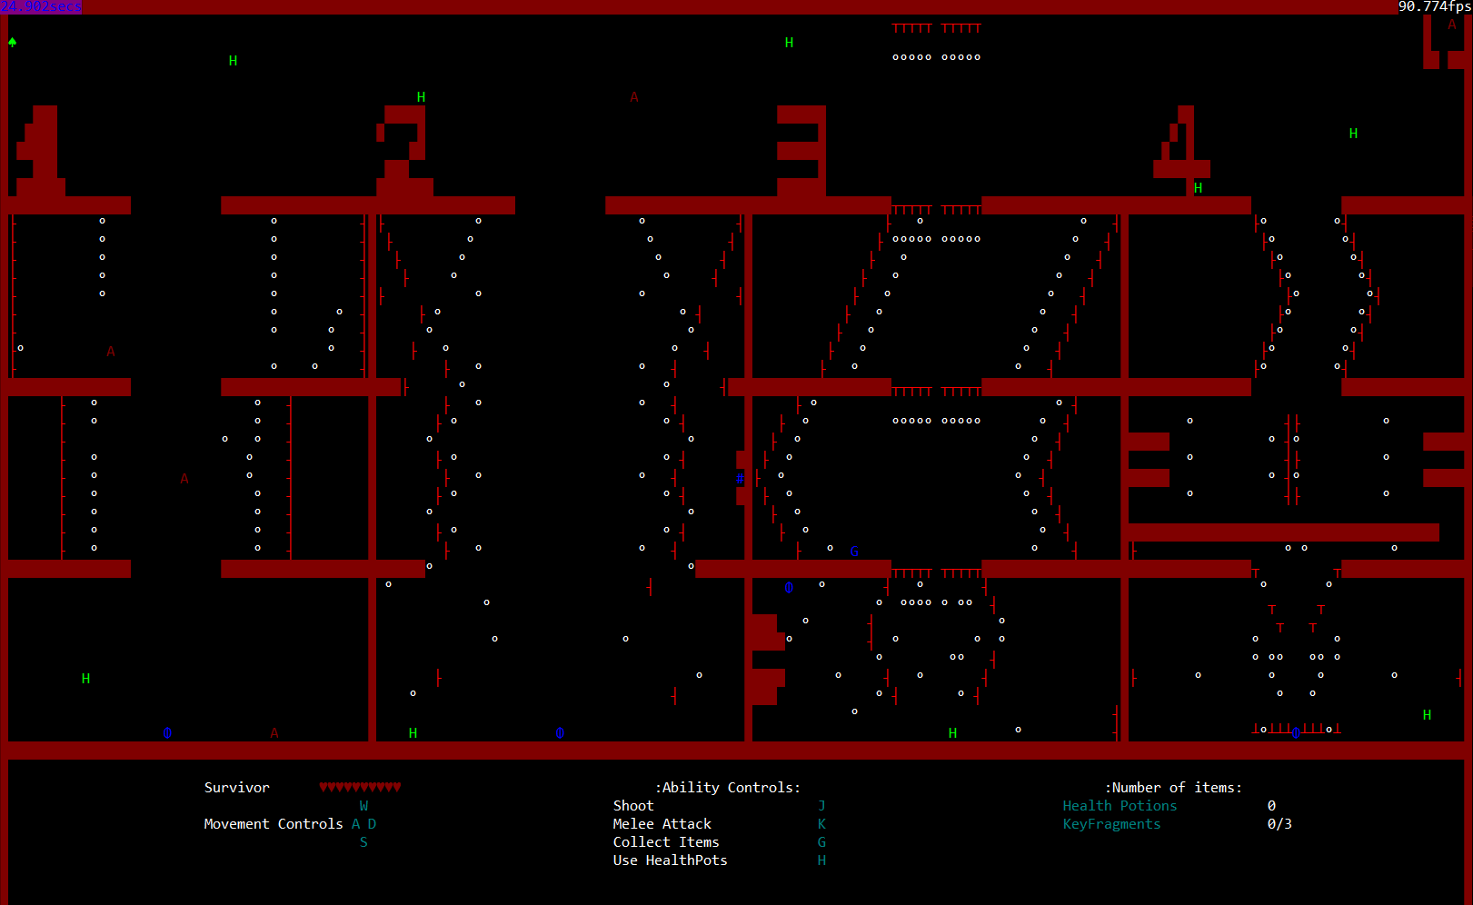

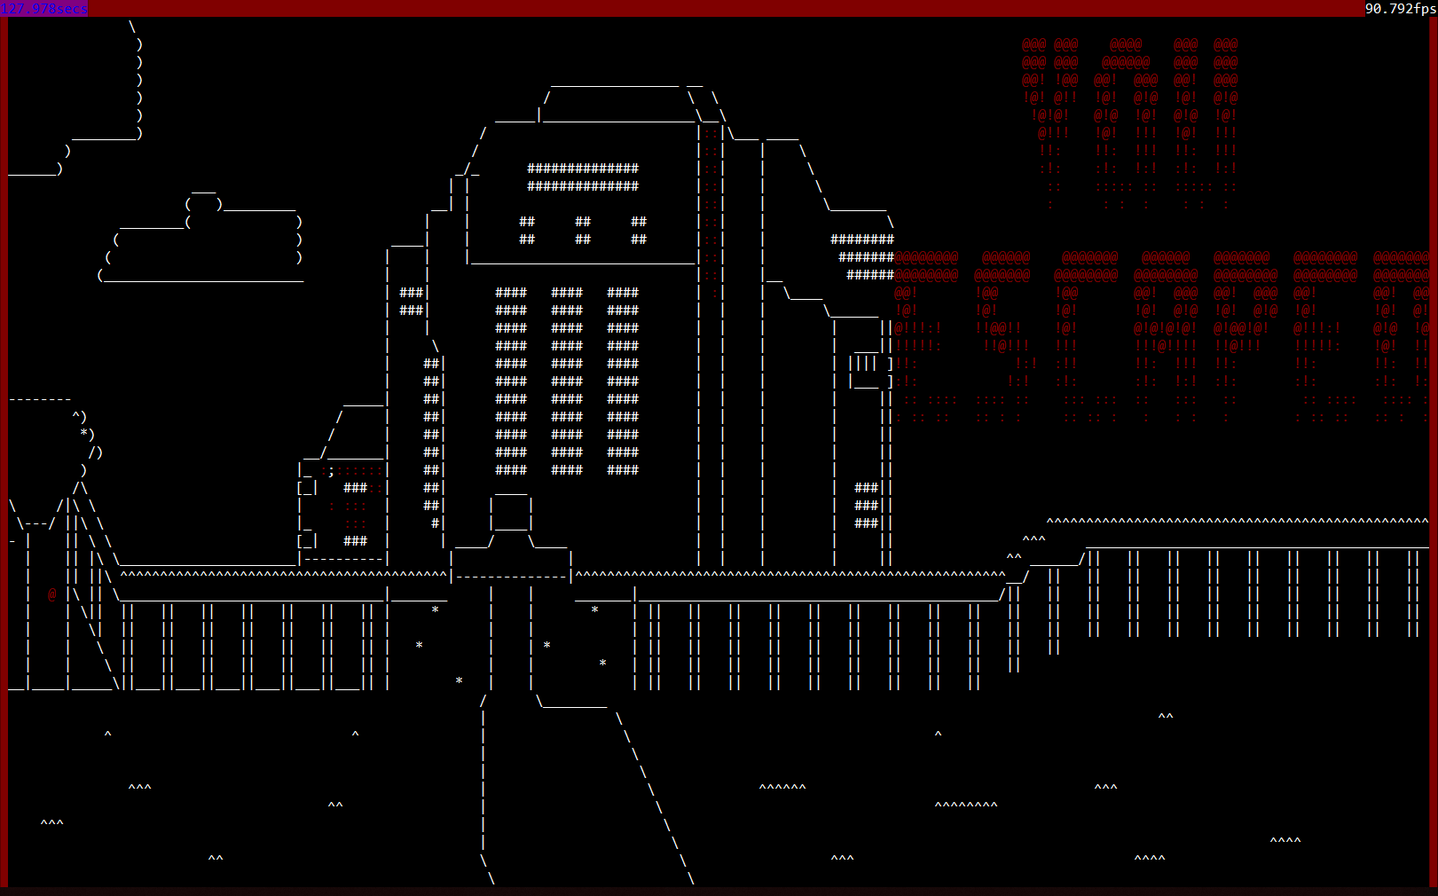

Knowledge used

* Pointers
* Object-oriented programming
* Functions
* Reference
* A* Pathfinding
* Loops
* Enums

Description of Features

* **Different Character for the Survivor to choose after obtaining 3 Shrines**
  + There will be 4 Characters for the Survivor to choose from after fixing 3 Generators
  + Once Chosen, they will not be able to change to other Character
  + Each Character has a different Special Ability which could help the survivor to kill the Killer and can alter the maze
* **Ability to alter the Maze**
  + The survivor has the ability to place a Wall if there is no wall there and if there is, they are able to rotate the wall.
  + The Killer has the ability to break Walls
  + After the Survivor changes Character, they will also gain another ability that can also alter the maze
* **Fog of War**
  + Both the Survivor and the Killer can only see a few blocks around themselves
  + The Killer has an ability which allows him to Blackout the Survivor surrounding for 3 seconds
  + The ability has a cooldown of 5 seconds
  + When an ability is used or a block is broken, the Fog of War will be paused until the effects/ability is over
* **AI**
  + We have several AIs that patrols different areas and when a player is close to the AI, the AI will chase after the player
  + However, When the player is far enough, the AI will stop chasing them and go back to patrolling the area
  + Only used in Solo gamemode

Problems we encountered

* Edward’s Problems & Solution
  1. Making an A*Pathfinder
     + Solved by searching on the internet and watching YouTube videos of various A* pathfinding
     + Nigel who had some experience with A* pathfinding, helped guide me through parts that I cannot figure out
  2. Rendering of bullets
     + Took my time and slowly debug and figure out how to do so.
     + Used vector to store the Coordinates of each bullets and a for loop to move the bullet and render the bullets
* Nigel’s Problems & Solution
  1. Making the rotation
     + I originally planned to use matrix to rotate blocks 90 degrees however I decided to go with a for loop that offsets the ‘blocks’ based on their distance away from the origin and distanced them in the other axis
  2. Particle System
     + I decided to develop a Particle System that would manage all particles related effects. The issue was that the particle system had to manage collision as well. So I created an enum that would classify particles thus it would handle collision based on the identifier I gave it.
  3. Optimising the solution
     + The rendering of the map originally required a lot of if statements. Thus, I decided to use the Entity Class that we made to facilitate the rendering of the map without checking.
* Aorion’s Problems & Solution
  1. Getting the right colours for UI and making instructions clearer.
     + Solution for the colours was to keep trying them out because at first I wanted the effect of making it scary but then realised that it was hard to see so at first I just adjusted the colour for the specific controls but in the end just changed all of them
     + Problem for making instructions clearer was the fact that no one wanted to to read and even if they did they would forget so my solution was to make a tutorial mode for players.
* Rong Sheng’s Problems & solution
  1. Getting sounds to play
     + At first, I tried using the windows.h playSound() function to play the sounds. I thought I would work with multiple sounds, but I was quickly proven wrong. When I tried to play multiple sounds at once, it would stop the previous sound and play the new one. Thus, I decided to move to use the Irrklang Library.
  2. Playing Multiples sounds at once
     + I had trouble using the windows.h playSound() function to play multiple sounds. Thus, I went online and found the Irrklang Library to fix this problem, and I was then able to play multiple sounds at once without stopping the previous sound.
  3. Getting turrets to shoot out projectiles continuously
     + When making the turrets, I had trouble

Future Enhancements

* Coming up with more characters Survivor can choose from
* Allow the Killer to also choose character
* Allow 2 more player to join the game making the game a four-player game
* Make maps more interactive e.g. adding power-ups, adds buttons/ pressure plates that rotates the walls